TCP 2201
Object Oriented Analysis and Design
Trimester 2, 2016/2017

Barsoom Chess
Version 1.0

by Team Chill,

Team Leader:
Mohd Arif Danial bin Abdul Aziz, 1142702426

Team Member:
Shukri Armizi bin Md Hanif, 1142702491,
Muhammad Syawaludin bin Anas Yusof, 1142700818,
Hamizan Adli bin Ahmad Shafie, 1142702495,
Ahmad Haziq Khan bin Abdul Haddy Khan, 1141126629,

Faculty of Computing and Informatics,
Multimedia University, 63100, Cyberjaya,
Selangor Darul Ehsan, Malaysia.
1142702426@student.mmu.edu.my ,
019 333 7943
- INTRODUCTION
The purpose of this report is to introduce our implementation of Barsoom Chess for this assignment. This report also will cover the documentations of the program, the Universal Modelling Language (UML) Use-Case diagram, the Sequence diagrams, the Class diagrams and some instructions on running the program and how to use the program.
This is a compulsory assignment in the course TCP2201 Object Oriented Analysis and Design, given by the Faculty of Computing and Informatics at Multimedia University, Cyberjaya, Malaysia, in December 2016.

- UML USE-CASE DIAGRAM
The following is a Use-Case diagram for our Barsoom Chess program:
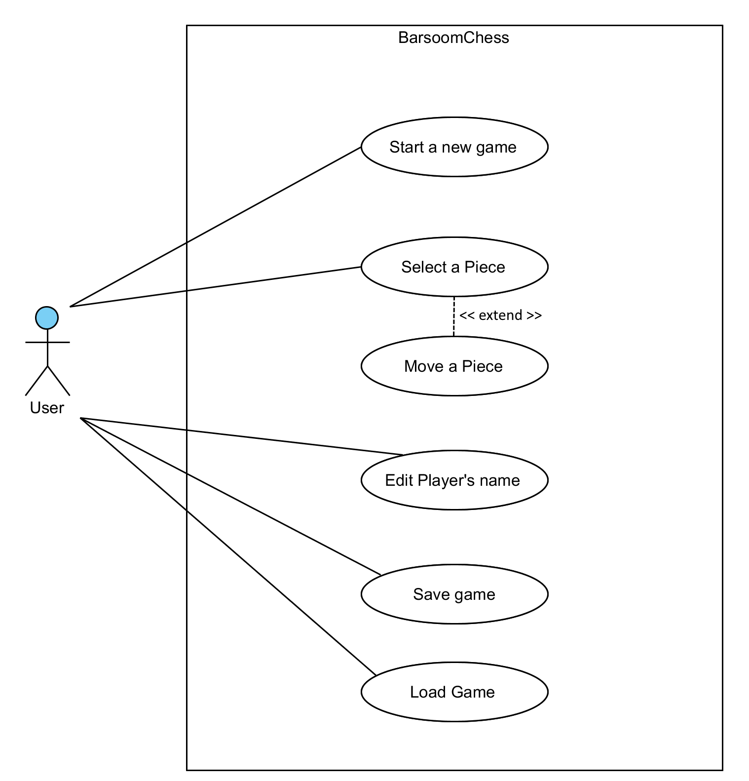
Diagram 1.0
Use-Case diagram for the program

- UML SEQUENCE DIAGRAM
The followings are Sequence diagrams for our Barsoom Chess program, based on the Use-Case diagram:
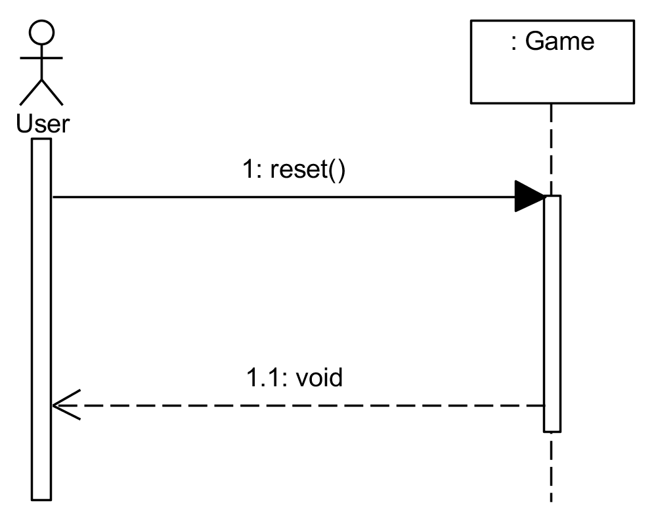
Diagram 2.0
Sequence Diagram for Start a new Game

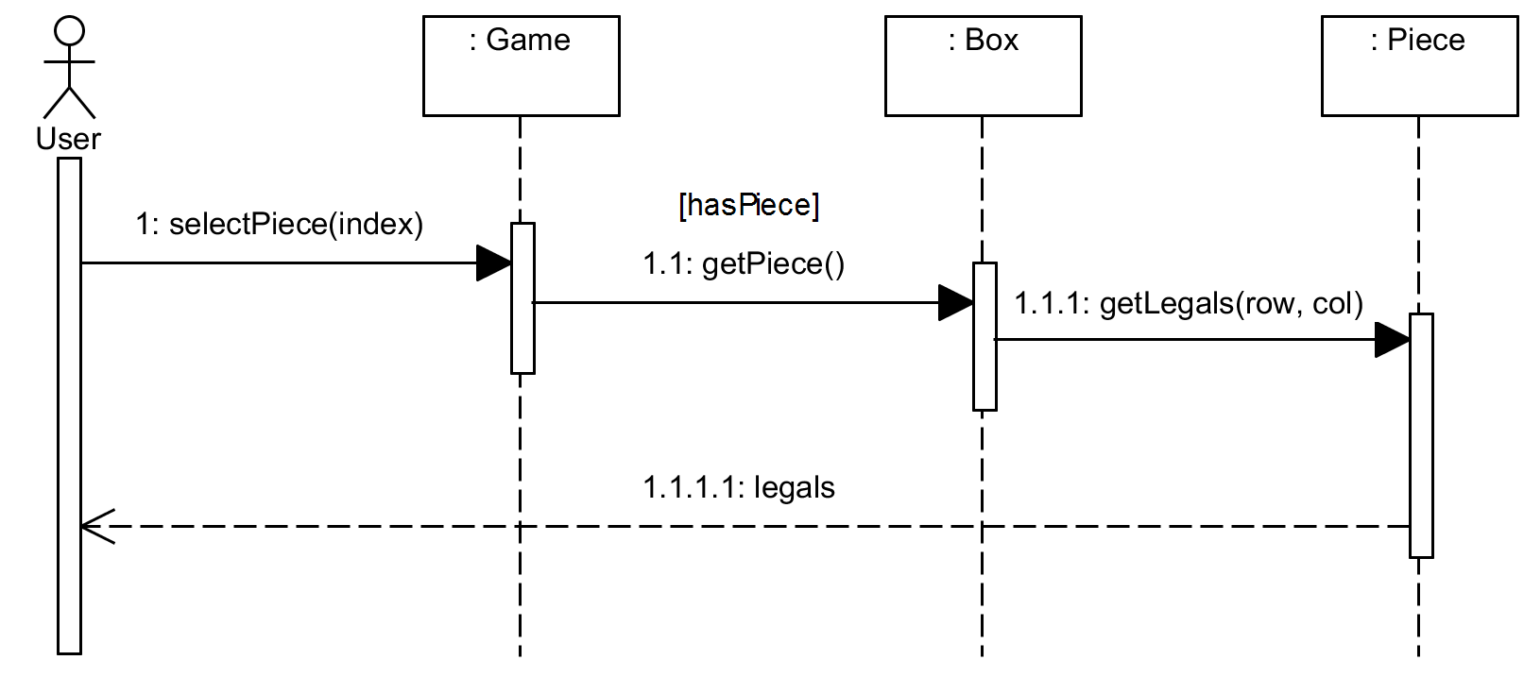
Diagram 3.0
Sequence Diagram for Select a Piece
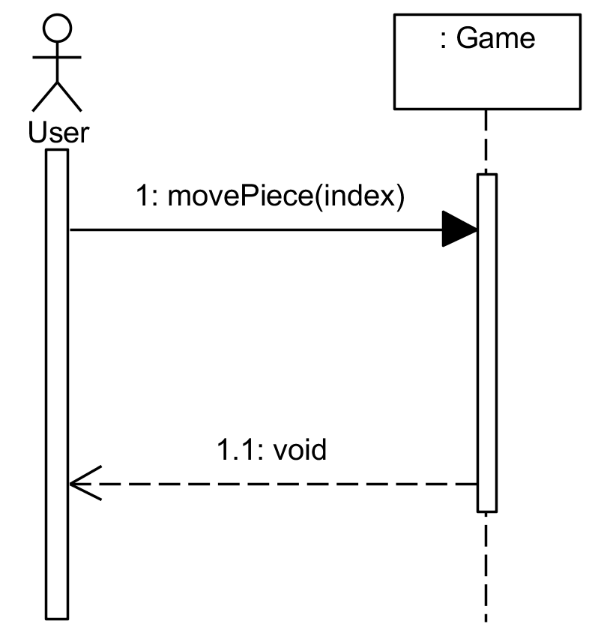
Diagram 4.0
Sequence Diagram for Move a Piece

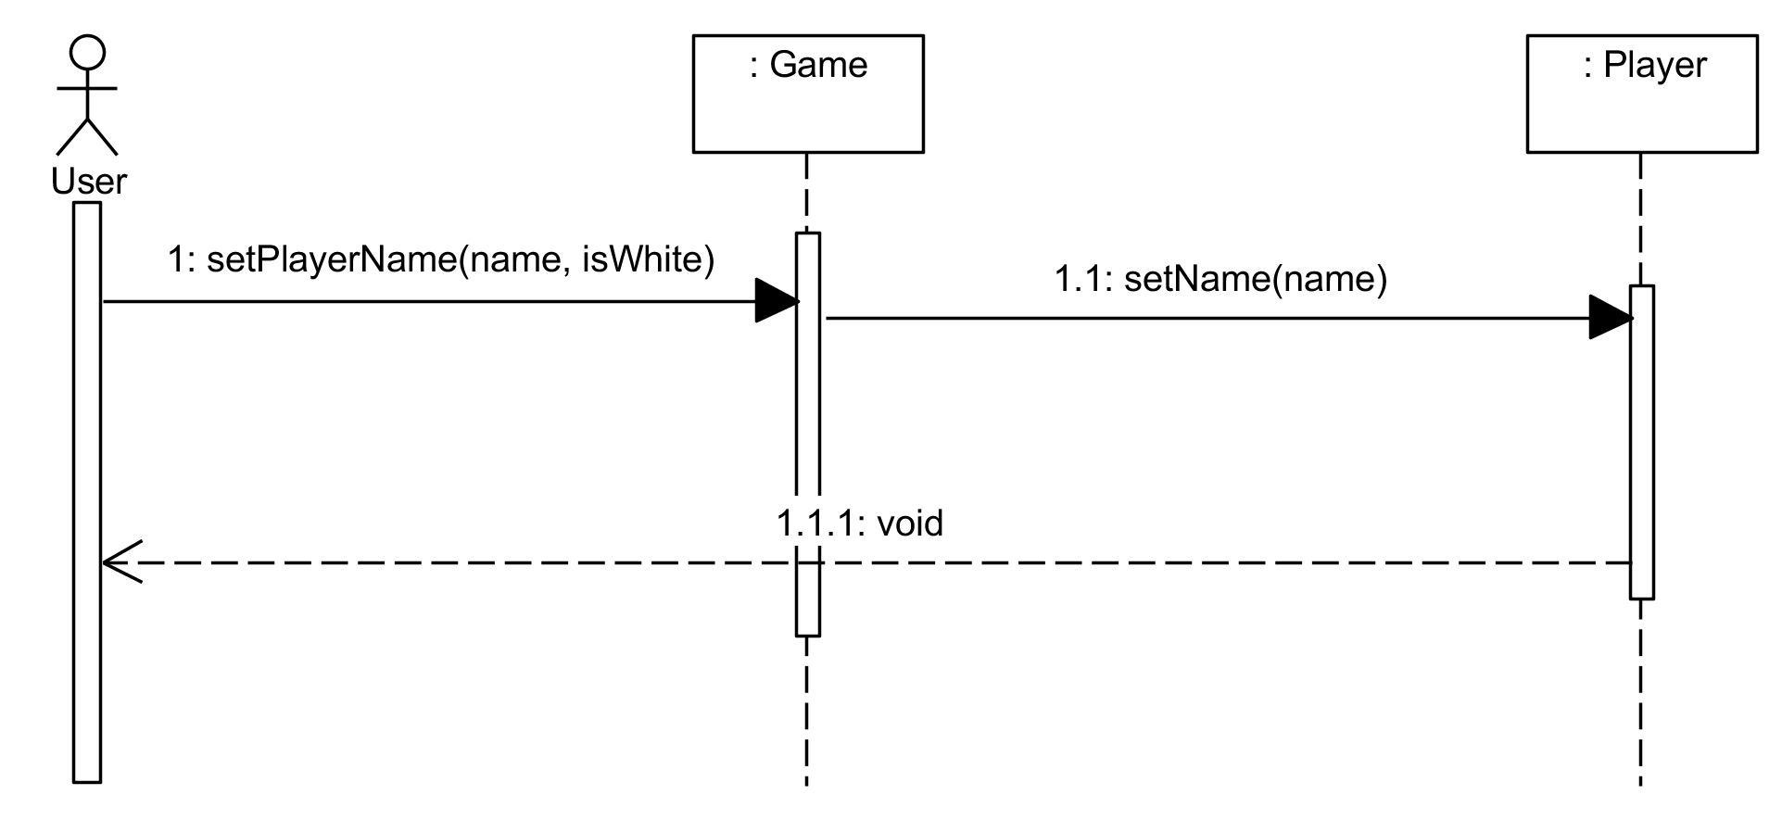
Diagram 5.0
Sequence Diagram for Edit Player’s name
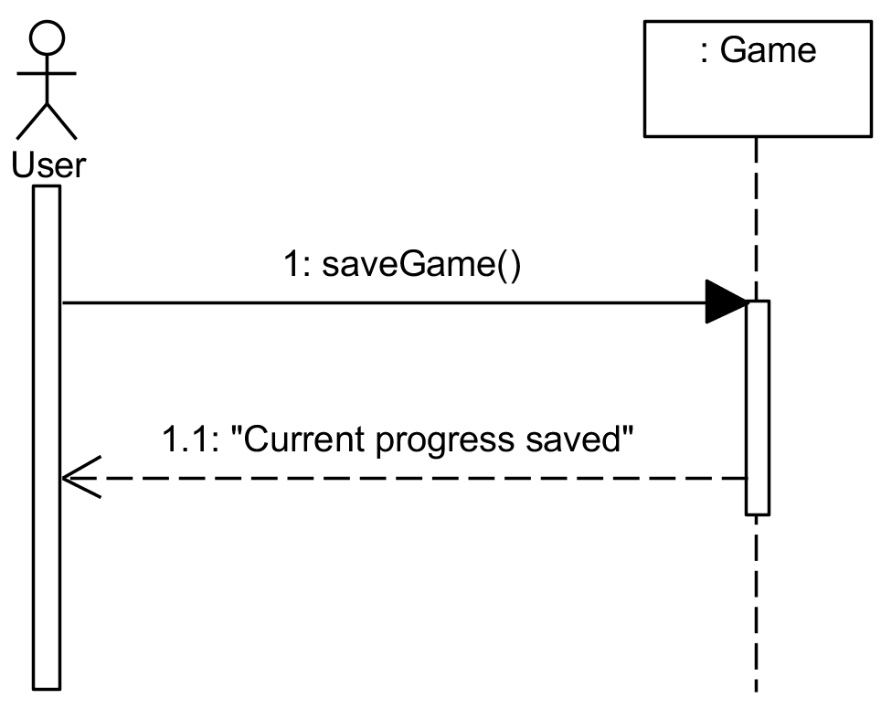
Diagram 6.0
Sequence Diagram for Save Game.

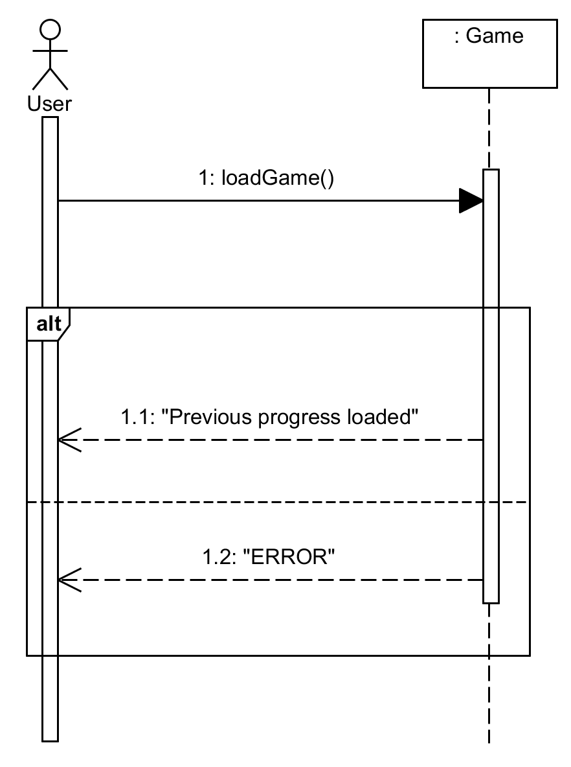
Diagram 7.0
Sequence Diagram for Load Game

- UML CLASS DIAGRAM
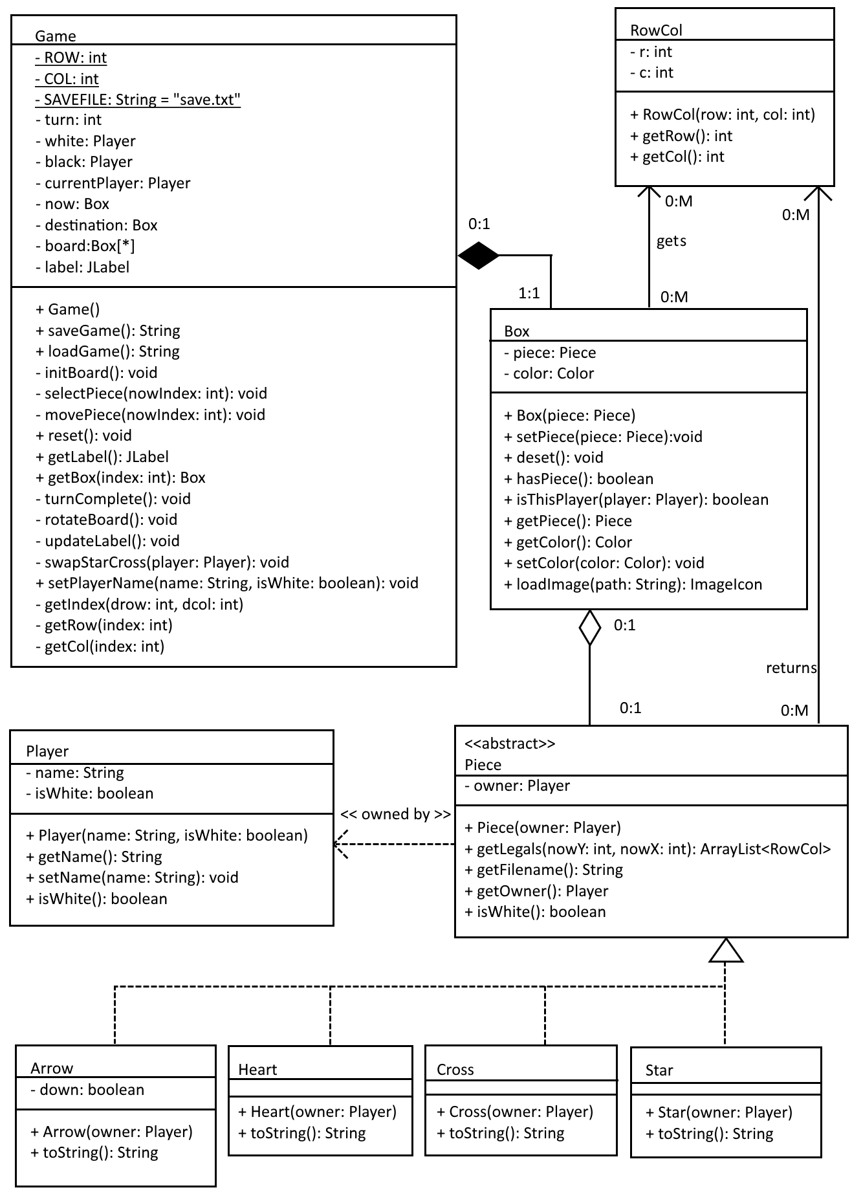
Diagram 8.0
Class Diagram for Barsoom Chess program.
The program was developed to simulate a game called Barsoom Chess, which contains a Heart, Arrow, Cross and a Star. This game is played on 8 by 5 grid board. What makes Barsoom Chess special is each time the turn count is a multiple of 4, the Cross will become the Star and the Star will become the Cross. In order to win in this game, one of the player has to take down the enemy’s Heart, while using the player’s other pieces to protect their own Heart.
Based on Model-View-Controller (MVC) pattern, every software has their own View, Model, and Controller. As for this program, the “View” of the program, which is the Chess class, is where the Graphical User Interface (GUI) creation for the program took place, which is why we did not include the Chess class inside the class diagram.
Next, the “Model” for the program is Player class, Box class, RowCol class, Piece class, Heart class, Arrow class, Cross class and the Star class. These classes holds important information to make sure the game works as designed. The Player class provides the information about the user(s) of the program, such as the player’s name, the player’s side of the game and can be used to identify the enemy of the player. The Box class provides the information of a one unit of the game’s board inside the program. The RowCol class basically provides information about the row and column of an object inside a grid. The Piece class is an abstract class which will be inherit by all types of pieces exist inside the game, which is the Heart class, Arrow class, Cross class, and the Star class, of course, which has their own rules.
Then, the “Controller” of the program is the Game class, which holds the logic of the game, to make sure the game is playable as the original Barsoom Chess.

- INSTRUCTIONS
The followings are the instruction to execute the program:
- Extract the “Chill_BarsoomChess.zip” to the desired location.
- Launch command prompt, change the current directory to folder “chess” inside the extracted folder.
- Type in “javac *.java”, and press Enter, to compile.
- When compiling is done, type in “java Chess”, to run the program.

The followings are the instruction on how to play the game:
- The player that is making the current move is always at the bottom of the board.
- Click a Piece to start making a move,
- After the player has clicked on a Piece, the player can click at the next Box as destination. If the Box is GREEN, the Box is one of the legitimate destinations. If the Box is BLUE, the Bo is one of the legitimate destinations and contains the enemy’s Piece which the player can take it down. If the Box has no colour, the game will cancel the move, and will allow the player to pick another Piece.
- To win, the player has to take down the enemy’s Heart, while protecting the player’s Heart.
- To restart a new game, click Menu > New Game (Ctrl + N).
- To edit players’ name, click Menu > Edit Player’s name (Ctrl + E).
- To save current progress, click Menu > Save game (Ctrl + S).
- To load previous saved progress, click Menu > Load Game (Ctrl + L).
- To learn each piece’s legal moves, click About > How to Play.
- ACKNOWLEDGEMENT
To begin with, we would like to thank Mr. Soo Wooi King for the advices and teachings he gave us in preparing the documentation, and for reading upon most of the program development. As Mr. Soo Wooi King experience in object-oriented design and put his time on sharing and teaching us the knowledge, we have overcome a lot in designing and developing this program.
We would like to acknowledge the help we received from stackoverflow community who has been helping and solving the problem we faces during the development of the program. As the community have gave tons of references and information which are related on Java programming language itself and Java Swing, which is an Application Programming Interface (API) to create the GUI for a Java program, which can help upon completing this assignment.
It is impossible to develop this program without the help we gained from the lecturer and the stackoverflow communities on developing this program. Therefore, we gratefully acknowledge the assistant from these wonderful people.

- REFERENCE
1. https://www.tutorialspoint.com/java/
2. http://docs.oracle.com/javase/7/docs/technotes/guides/swing/

TCP2201 Project Evaluation Form (30%)
Project Due Date: Wednesday, 6 February, 2017. Late policy applies until Sunday, 9 February 2017.
Tutorial Section: | TT02
Team Name: | CHILL
Group Leader: | MOHD ARIF DANIAL BIN ABDUL AZIZ - 1142702426
Member | SHUKRI ARMIZI BIN MD HANIF - 1142702491
Member | MUHAMMAD SYAWALUDIN ANAS YUSOF – 1142700818
Member | HAMIZAN ADLI BIN AHMAD SHAFIE – 1142702495
Member | AHMAD HAZIQ KHAN BIN ABDUL HADDY KHAN - 1141126629

Prototype and Presentation (20%)
Item | Maximum marks | Actual Marks
Comments, indentation, following proper Java naming conventions, other Java style issues. | 2
Object-oriented concepts like subclassing, delegation, composition, aggregation, polymorphism, etc. | 3
Appropriate use of Design Patterns | 3
User friendliness and appropriate GUI components used, windows resize properly and the board scales properly, menus still work during game play, etc. | 4
Functional requirements fulfilled, e.g. players can play through a game properly, all the pieces move and transform correctly, winner is declared, save game, load saved game, etc. | 8
Total: | 20

Report (10%)
Item | Maximum marks | Actual Marks
Use Case Diagram done and is coherent with the implementation | 2
UML Class Diagram done and is coherent with the implementation | 3
Sequence Diagrams done and is coherent with the implementation | 3
User Documentation done and is coherent with the implementation | 2
Total: | 10

